In Java, String is immutable, meaning that once a String object is created, its value cannot be changed. This design decision has several significant advantages, which stem from performance, security, and functional reasons.

Reasons for String Immutability in Java
- Thread-Safety:
  - Since String objects are immutable, they are inherently thread-safe.
  - Multiple threads can safely access the same String instance without synchronization, avoiding concurrency issues.
- Caching and Reusability (String Pool):
  - Java uses a string pool to store literal strings. When a string is created, the JVM checks if it already exists in the pool.
  - If it does, the reference to the existing string is returned, saving memory.
  - This is only possible because strings are immutable; otherwise, modifying one reference would affect all others.
- Security:
  - Strings are often used to store sensitive data like usernames, passwords, and file paths.
  - Immutability ensures that their values cannot be altered after creation, reducing vulnerabilities.
  - For example, if strings were mutable, a malicious thread could modify a file path during a security check.
- HashCode Consistency:
  - The hashCode of a String is frequently used in collections like HashMap and HashSet.
  - Immutability ensures that the hashCode of a String remains constant, making strings reliable as keys in hash-based collections.
- Performance in Collections:
  - Since String is immutable and its hash code doesn’t change, it doesn't require recomputation when used in hash-based data structures, leading to better performance.
- Ease of Implementation:
  - Immutability simplifies many aspects of programming by eliminating certain bugs related to accidental changes.
  - Developers can rely on a String instance to remain constant throughout its lifetime.
- Design Philosophy:
  - Strings are heavily used in Java, and immutability aligns with the language's emphasis on safety and robustness.
  - Immutability allows String objects to be reused across different parts of an application.

Illustrative Examples

Example 1: String Pool Behavior
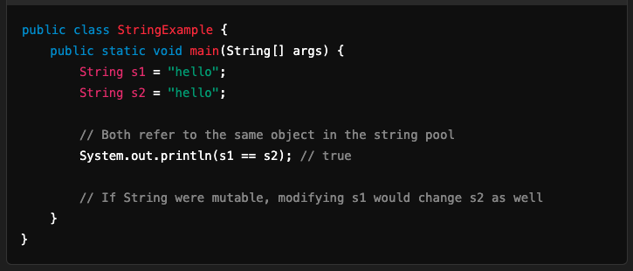

Example 2: Immutability and HashMap
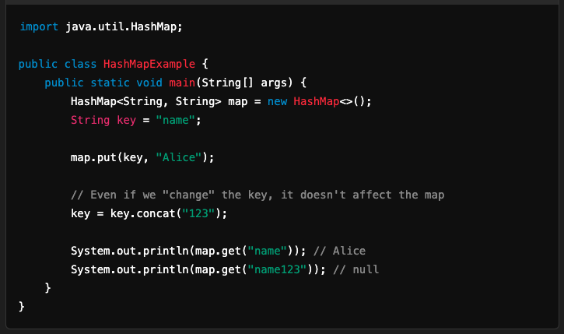

Immutability in Practice
While String is immutable, the StringBuilder and StringBuffer classes are mutable and are used when frequent modifications are needed. For example:
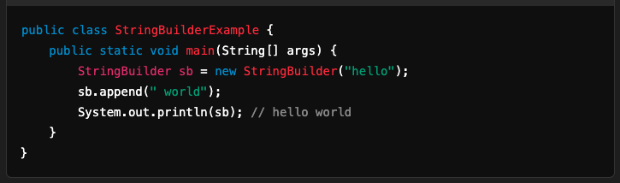

Conclusion
String immutability is a foundational design choice in Java that improves efficiency, security, and consistency. When you need mutable behavior, you can use alternatives like StringBuilder or StringBuffer.

